Introduction to MATLAB
MATLAB ( MATrix LABoratory) is a programming and numeric computing platform developed by MathWorks. It is widely used by engineers, scientists and researchers for solving mathematical problems, analysing data, developing algorithms and creating models.
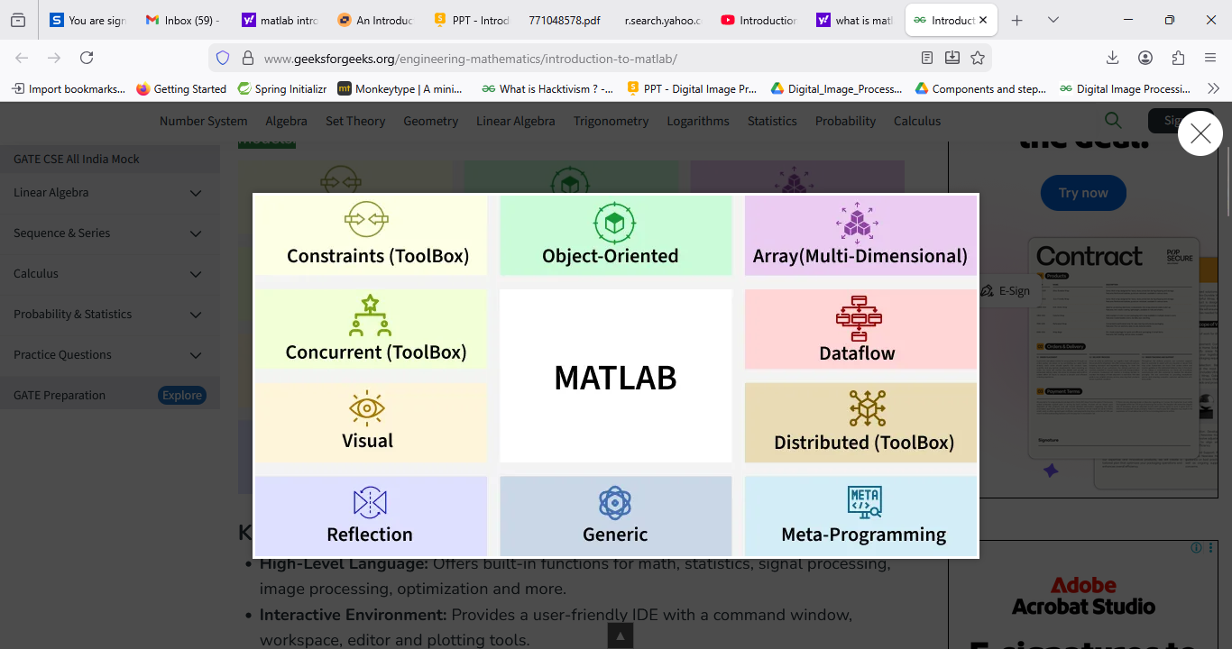

Key Features of MATLAB
- High-Level Language: Offers built-in functions for math, statistics, signal processing, image processing, optimization and more.
- Interactive Environment: Provides a user-friendly IDE with a command window, workspace, editor and plotting tools.
- Toolboxes: Specialized collections of functions for various domains like machine learning, control systems and image processing.
- Visualization: 2D and 3D plotting capabilities for visualizing data and results.

Simple MATLAB Example
x = 0:1:10; % x values from 0 to 10
y = 2 * x + 1; % y values based on the equation y = 2x + 1

plot(x, y) % Plot the line
title('Line Graph of y = 2x + 1')
xlabel('X Values')
ylabel('Y Values')
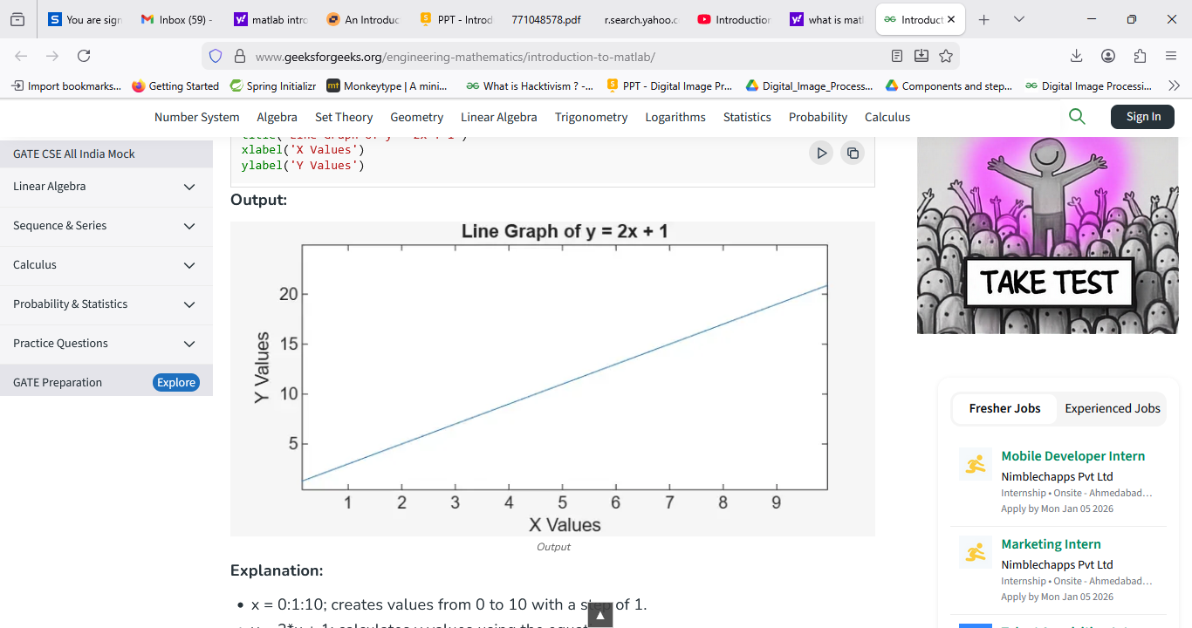
Explanation:
- x = 0:1:10; creates values from 0 to 10 with a step of 1.
- y = 2*x + 1; calculates y values using the equation.
- plot(x, y) draws the graph.
- title, xlabel and ylabel add labels to the graph.

Basic MATLAB Workflow
Using MATLAB usually involves these steps:
- Entering Commands: Use the Command Window to run calculations directly.
- Writing Scripts: Save sequences of commands in .m files for reuse.
- Running Functions: Use built-in or user-defined functions for specific tasks.
- Visualizing Results: Create plots and graphs to analyze data.

MATLAB Library
MATLAB comes with a large set of inbuilt functions. Many are for mathematical operations (like sin, cos, det, inv, dot, cross).
Unlike languages like C or Java, MATLAB does not require:
- Declaring data types before using variables
- Including header files at the beginning of programs
This makes operations such as vector and matrix computations much simpler, often requiring only a single line of code.

Basic Functions in MATLAB
Function | Description
disp() | Displays values or text on the screen
clear | Clears all variables from the workspace
close all | Closes all graphics windows
clc | Clears the Command Window
exp(x) | Calculates e^x
abs(x) | Returns the absolute value of x
sqrt(x) | Returns the square root of x
log(x) | Calculates natural logarithm (base e) of x
log10(x) | Calculates logarithm (base 10) of x
rem(x, y) | Returns the remainder of x/y
sin(x) | Returns sine of x
cos(x) | Returns cosine of x
tan(x) | Returns tangent of x
atan2(y, x) | Returns arctangent (inverse tangent) of y/x

Applications of MATLAB
MATLAB is used across various engineering, scientific and research fields. Some major application areas include:
- Signal and Image Processing: Used for filtering, compression, feature extraction, image enhancement and audio analysis.
- Control Systems Design: Helps design, simulate and analyze control systems using built-in toolboxes and Simulink models.
- Data Analysis and Visualization: Used to clean, process, analyze large datasets and present results through interactive 2D/3D plots.
- Machine Learning and Deep Learning: Supports building, training and evaluating predictive models using specialized toolboxes and frameworks.
- Simulation and Modeling of Physical Systems: Used to create mathematical models and run simulations to study system behavior under various conditions.

MATLAB Tutorial
MATLAB is a programming platform used for mathematics, engineering and scientific computing. It provides built-in tools for calculations, visualization and application development. It is often chosen for tasks that require accuracy, speed and clear presentation of results.
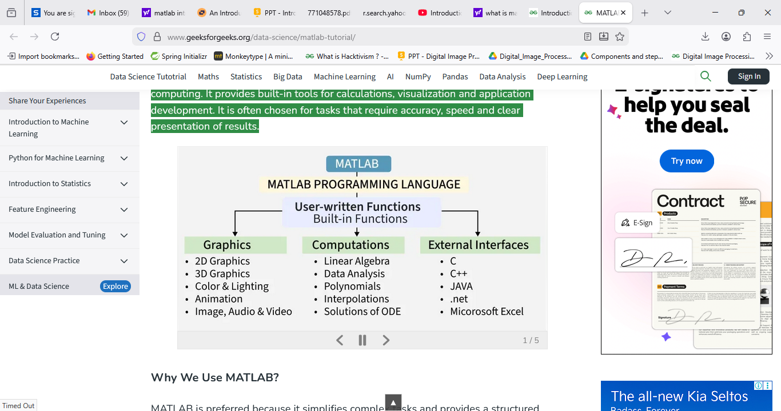




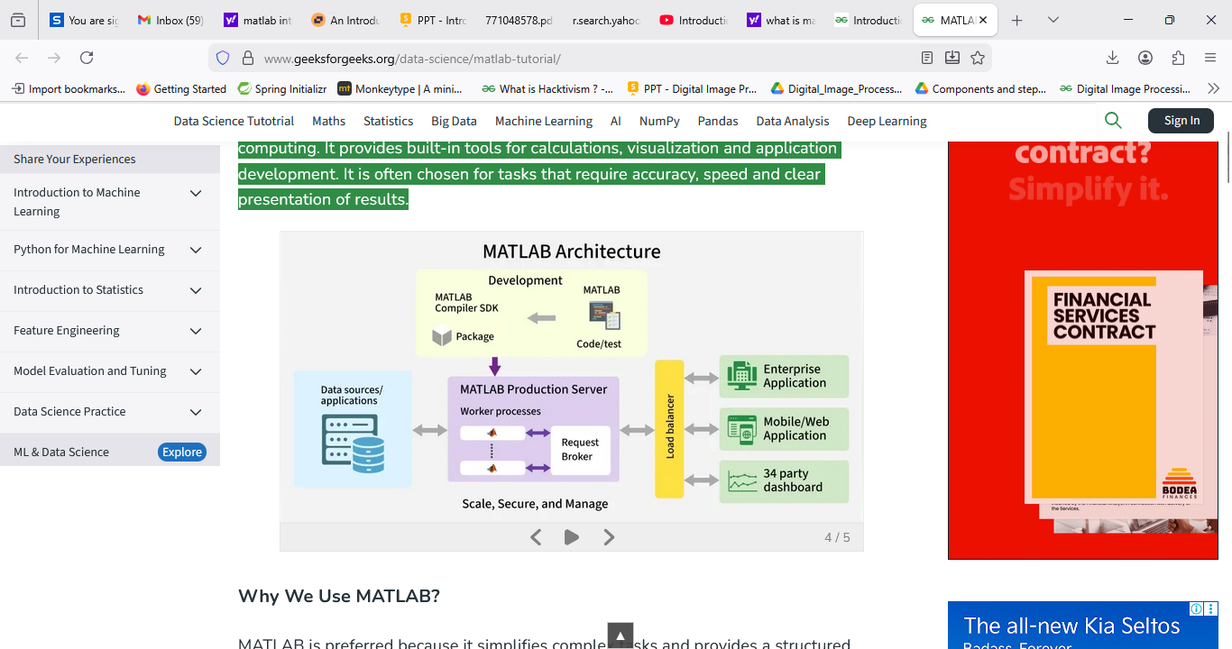



MATLAB Basics
Covers the fundamental building blocks of MATLAB such as variables, data types, syntax and commands. It also explains strings, classes and tables for organizing data.
- Variables
- Data Types
- Syntax
- Commands
- Symbolic variables
- Characters and Strings
- Classes and Object
- Tables

MATLAB - Variables
A variable in simple terms is a storage place that has some memory allocated to it. Basically, a variable used to store some form of data. Different types of variables require different amounts of memory and have some specific set of operations that can be applied to them. The Matlab workspace store all the variables that you create or use during a session.

Creating Variables
To create a variable enter the name of the variable in the command window, followed by an = operator, and then assign it some values.
Example:
% MATLAB code for variable initialization %
% First variable %
a=10;

% Second variable %
b=10;

% Third variable %
num=10;

% Fourth variable %
sum=100;

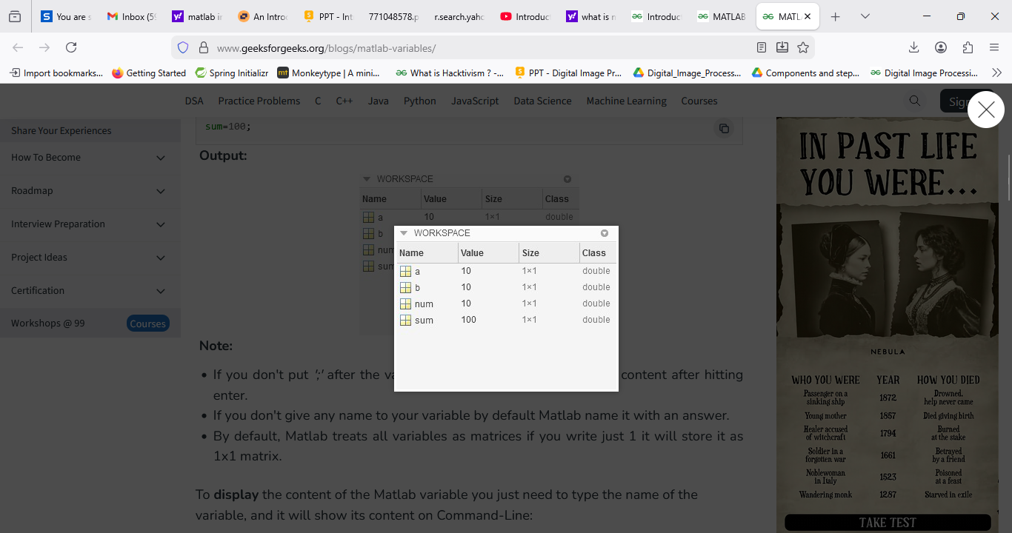
Note:
- If you don't put ';' after the variable name, Matlab will display its content after hitting enter.
- If you don't give any name to your variable by default Matlab name it with an answer.
- By default, Matlab treats all variables as matrices if you write just 1 it will store it as 1x1 matrix.
To display the content of the Matlab variable you just need to type the name of the variable, and it will show its content on Command-Line:
Example:
% MATLAB Code for display variable %
% value in command window %
% First variable 5
a
a = 100

% Second variable %
b
b = 200
Output:
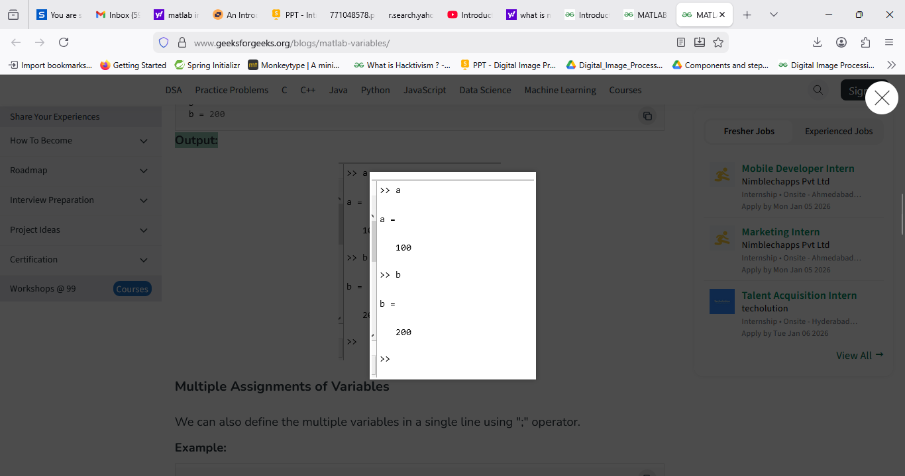

Multiple Assignments of Variables
We can also define the multiple variables in a single line using ";" operator.
Example:
% MATLAB code for multiple variable %
% assignment in single line %
x = 12; y = 2; z = x*y;
disp('Result z =');
disp(z);
Output:
Result z=24

Who command
Who lists in alphabetical order the names of all variables in the currently active workspace. To use this command variables should be present in the active workspace and memory allocated to each variable is necessary.
Example:
% MATLAB code for Who command %
x = 12; y = 2; z = x*y;
disp('Result z =');
disp(z);

who
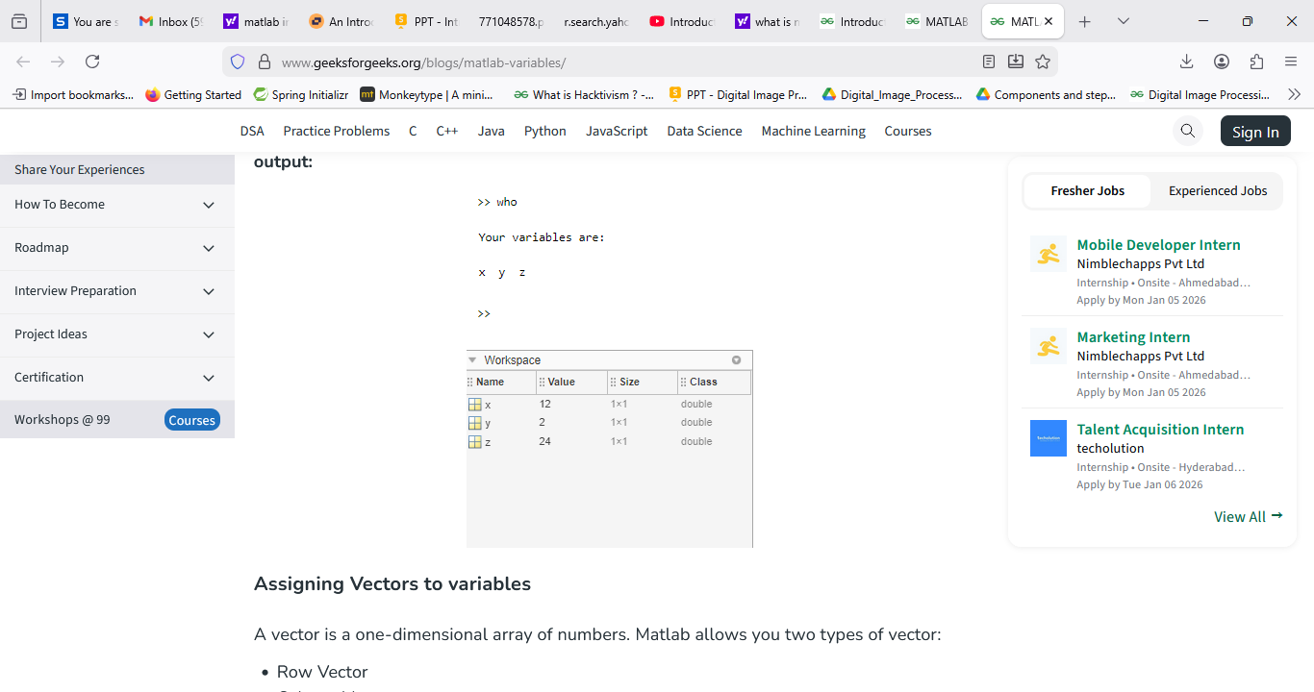

Assigning Vectors to variables
A vector is a one-dimensional array of numbers. Matlab allows you two types of vector:
- Row Vector
- Column Vector.
Row Vectors are created by enclosing numbers in square brackets separating with either space or comma.
Example:
% MATLAB program for row vector %
rowVector = [1 2 3 4 5]
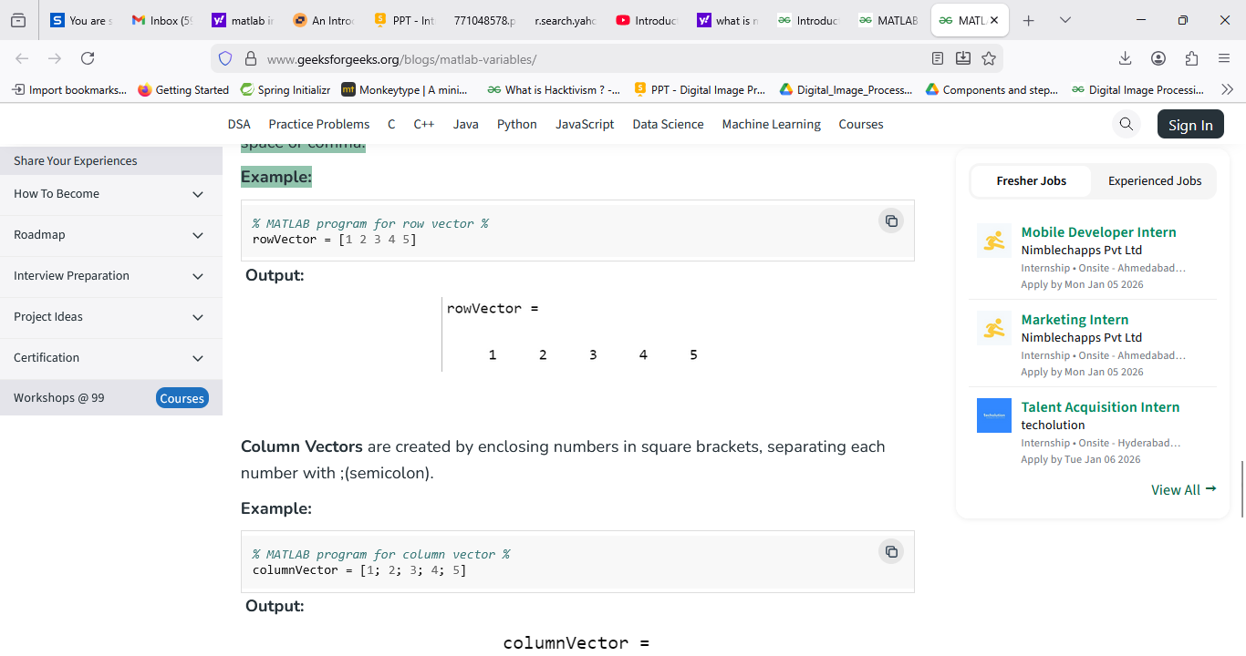
Column Vectors are created by enclosing numbers in square brackets, separating each number with ;(semicolon).
Example:
% MATLAB program for column vector %
columnVector = [1; 2; 3; 4; 5]
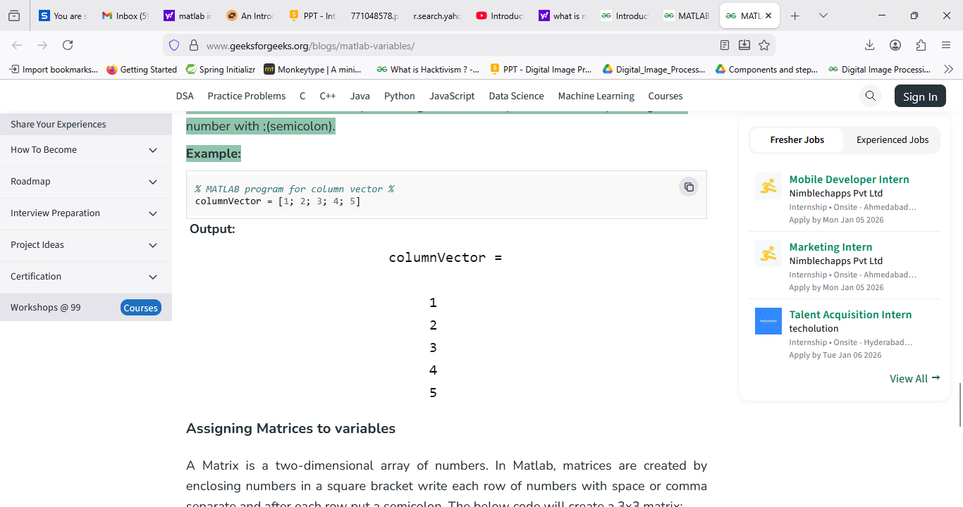

Assigning Matrices to variables
A Matrix is a two-dimensional array of numbers. In Matlab, matrices are created by enclosing numbers in a square bracket write each row of numbers with space or comma separate and after each row put a semicolon. The below code will create a 3x3 matrix:
Example:
% MATLAB program for 3x3 Matrix %
matalbMatrix = [ 1 2 3; 4 5 6; 7 8 9]

